## Findings Lambda Test (Cypress Integration) Vs Cypress scripts on PC Pre-requisites To Run Your Cypress Testing

## Step 1: Installing the LambdaTest CLI in the Cypress project. -npm install -g lambdatest-cypress-cli Step 2: Setup configurations on which you want to run your test, once you have installed the LambdaTest-Cypress CLI, now you need to setup the configuration. You can do that using the below command: -lambdatest-cypress init After running above command the lambdatest-config.json generated, where we need to configure and setup the lambda test, Below is the image of config file.

**Comparison and findings.**Lamdba Test Results vs Cypress Test Results.  
  
**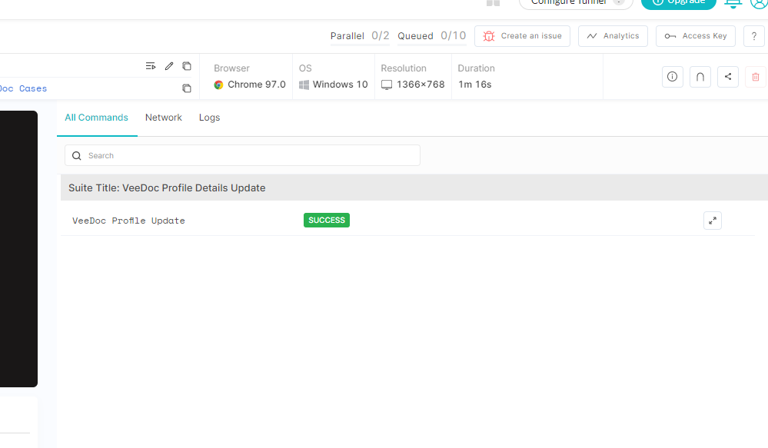  
  
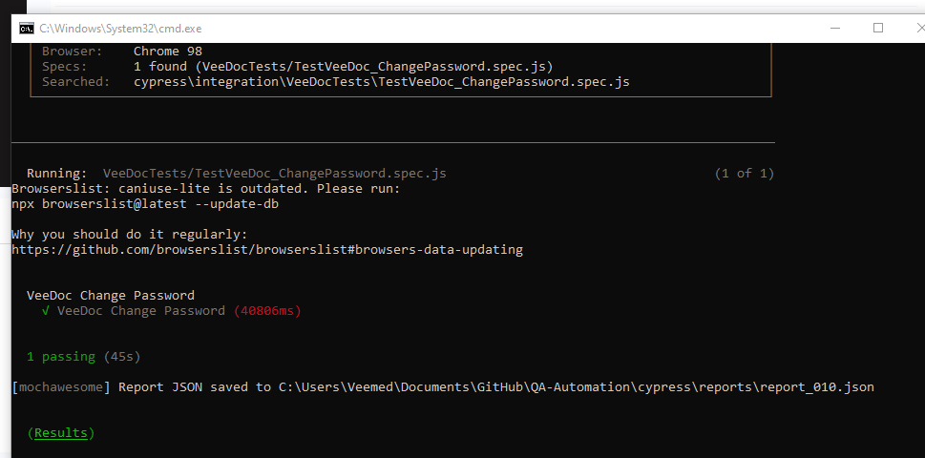**

Lamdba Test Console vs Cypress Test Console.  
  
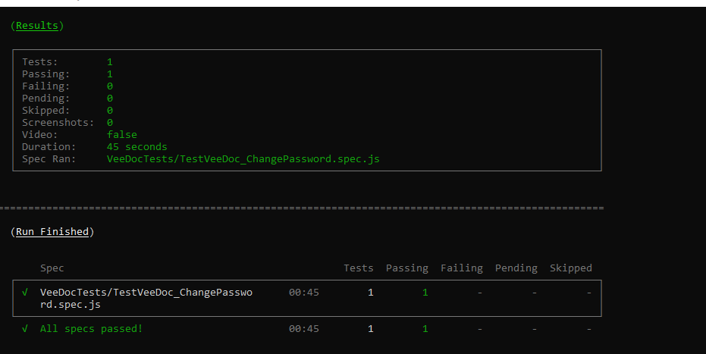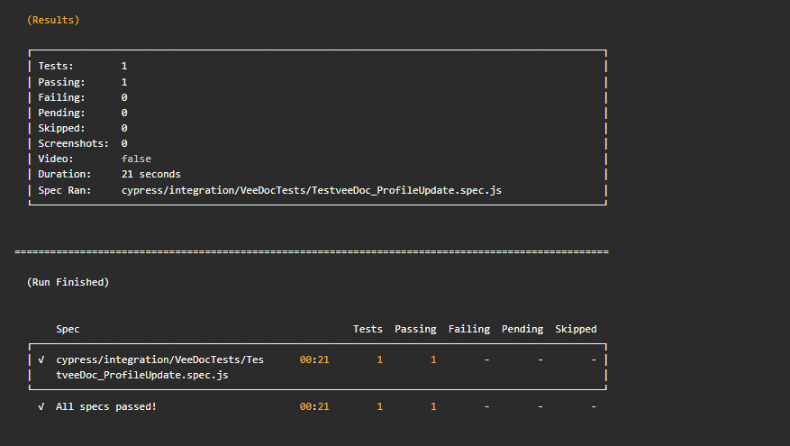

Lamdba Test Passed failed results vs Cypress Test Passed failed results along with duration.  
  
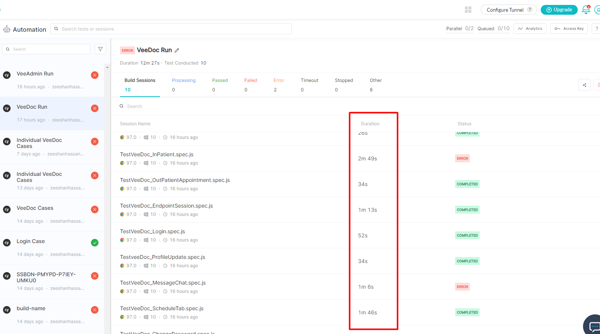  
  
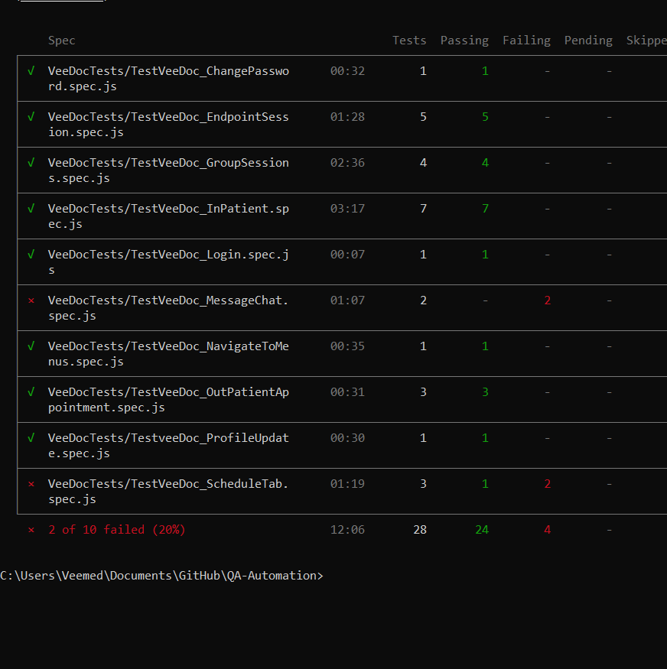

Same Test failed on Lamdba Test vs Working fine on Cypress pc.  
  
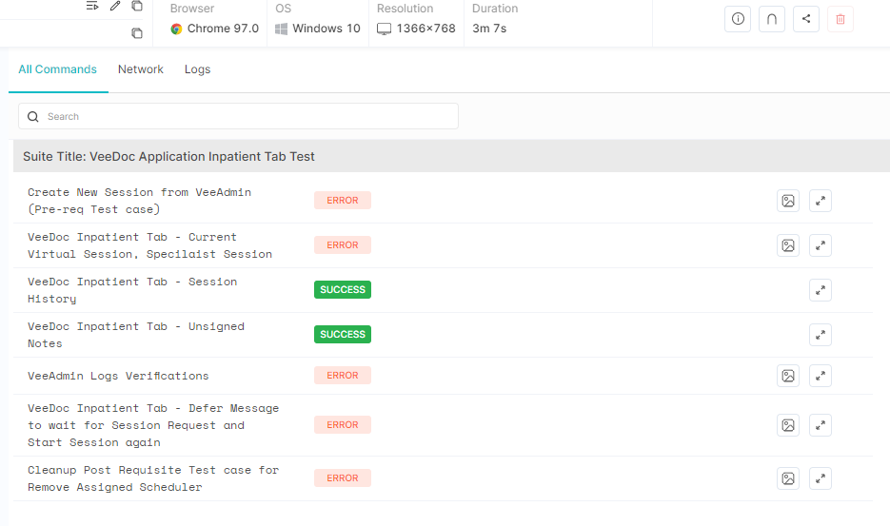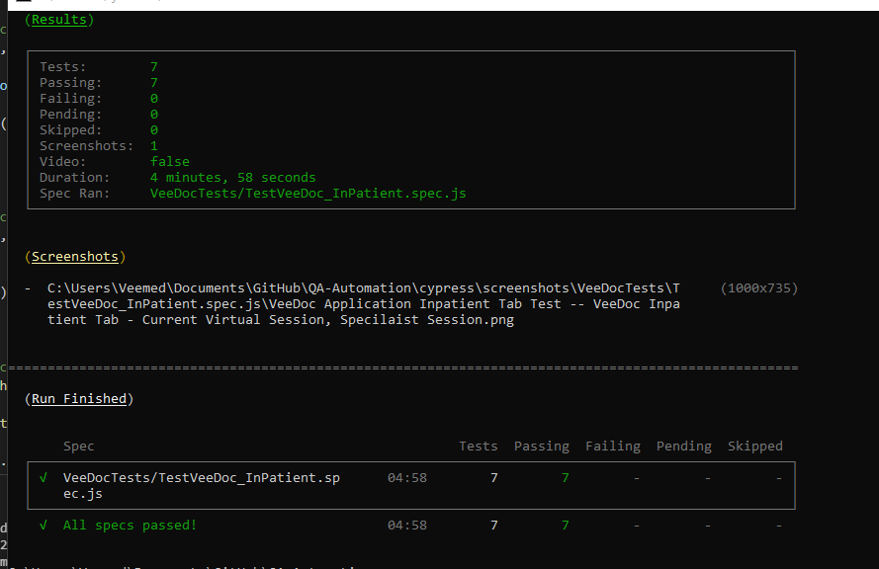

**Real Time Devices testing on Lambda Test, Browser and App Testing, Veekart Camera test.**

**VeeDoc Android Application.  
  
Google/ Samsung Google pixel 4A/ Samsung S20  
  
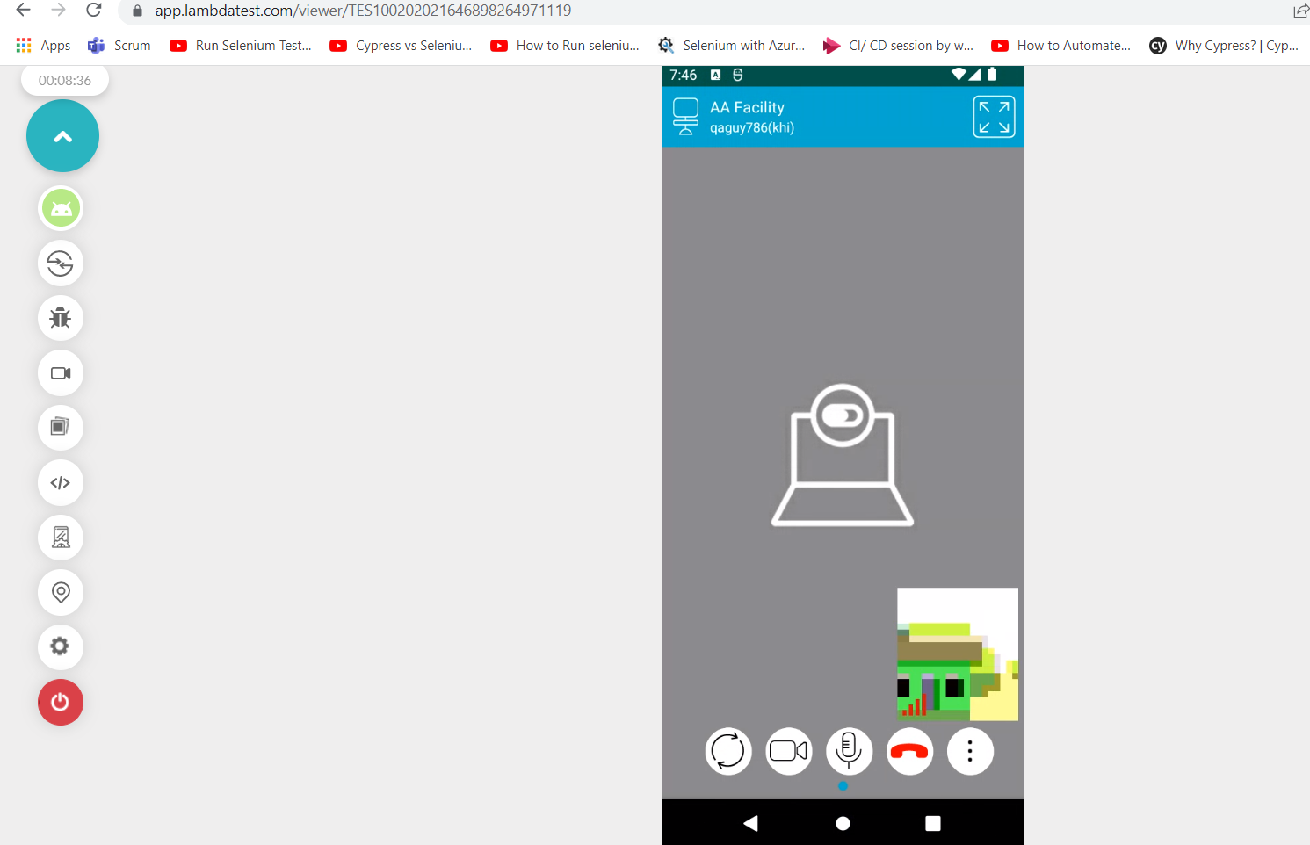**

**VeeDoc Web:  
  
